Figure 1. (12-point Times New Roman, italic). Force extension mean values of different joints for the gymnasts (continuous lines) and non-gymnasts (dotted lines) groups at the two assessments. Statistically significant differences at the 0.05 level between the two groups at each assessment are denoted by asterisks. Statistically significant differences at the 0.05 level between the two assessments for each group are denoted by arrows. (12-point Times New Roman, normal, plain font)

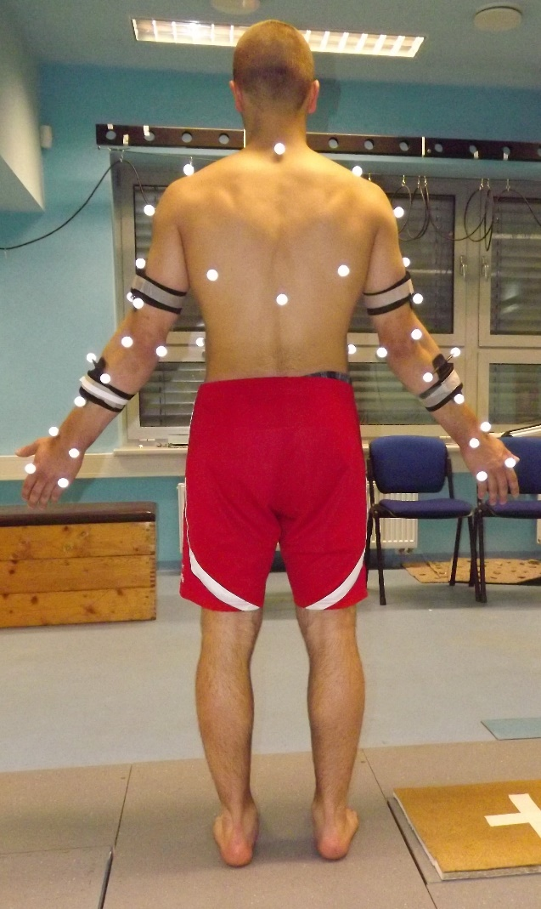
Figure 2. Marker placement on gymnast body.

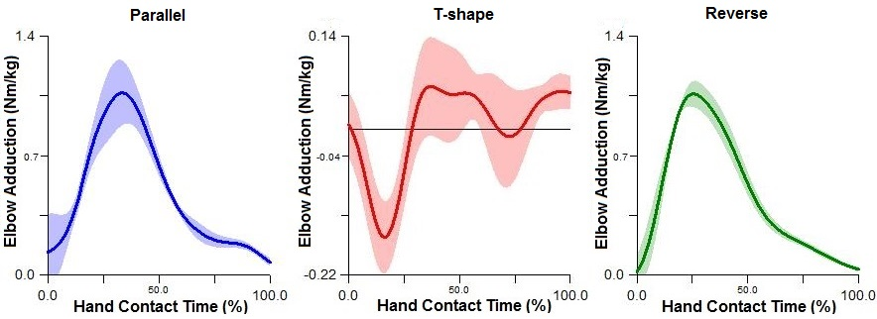

Figure 3. Elbow joint internal adduction moment of force profiles of the second contact hand in parallel (blue), T-shape (red) and reverse (green) techniques.

